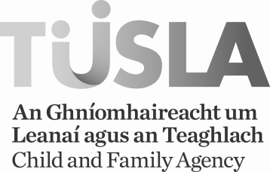

FOSTER CARERS URGENTLY NEEDED IN THIS AREA
April 2016
Dear Parent,
There is an urgent need for foster carers willing to provide a home for children and adolescents in this area.
Foster families are needed for children of all ages, from birth to eighteen years and beyond.
TUSLA, Child & Family Agency is currently running a campaign to find families who are willing to provide safe, loving and secure homes for children and adolescents.
Foster carers are needed to provide day foster care, short term foster care, respite and holiday foster care.
Fostering enquires are welcomed form married couples, single people, widowed, separated and divorced people. It is not necessary to be a parent. It is not necessary to own your own home. TUSLA respects and values cultural diversity and encourages enquiries from people of all ethnic origins.
Please read the attached leaflet for some more information on fostering including the supports offered to foster carers.
If you feel you could help by becoming a foster carer then please contact www.fostering.ie or 0766955550 for details of Fostering Information meetings in your area. By attending an Information meeting you will get a lot more information on fostering which will help you decide whether fostering may be a good option for you and your family.

Regards,

TUSLA, Child & Family Agency

