STARCAMP 2019 promises to be a magical one!

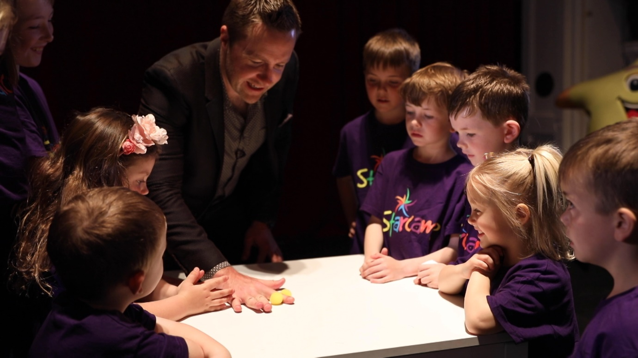

STARCAMP Summer Camps are back with a bang. Their 2019 Ambassador, magician, Keith Barry, was on hand to remind children of the Starcamp ethos, “Believe in yourself and you can achieve anything!” As STARCAMP kicks off their biggest and best Summer camp line up to date, they have teamed up with the renowned mind magician to send out a national reminder to parents everywhere that children’s positive mental health is their most important tool and that the use of the imagination, courage and self-esteem are essential for them for life.

“Starcamp is for everyone, not just the born performers” Keith Barry says. With over 40% boys now in attendance, it truly is a camp with broad appeal and its’ benefits are reaching boys and girls everywhere.

STARCAMP 2019, as always will include singing, hip-hop, acting, arts & crafts, confidence building, news-reporting, camp games, superheroes, star olympics, surprises galore – but there will be a special focus this year on Magic, the use of the imagination and Comedy! Staff at Starcamp HQ work all year round to ensure the most wondrous experience possible for all who attend. A little insight into this years’ line up shows Toy Story 4, The Lion King, Mary Poppins and David Walliams’ Gangsta’ Granny for the older kids. There will be George Ezra sing-offs, Disney classics and pop galore. The arts and crafts section will be imaginative and exciting and kids love using the microphones for the news reporting and interview section.

Starcamp was a memorable winner on Dragon’s Den, has won numerous awards and is widely recognised for leading the way in what it does. With a number of camps already booked out, don’t delay in securing your place. Every child receives a Starcamp t-shirt, cert, art supplies and lots more! The camp runs for 5 days from 9:30 – 2:30pm and children aged 4-12 will be sub divided into their own age groups for advancing programs. For a limited time, they offer an instalment option whereby €20 will secure your place.

BOOK YOUR LIMITED PLACE NOW AT WWW.STARCAMP.IE OR CALL 021-4377900.

